Module 4 - Asymmetric Encryption Algorithms

Slide 3 - Asymmetric encryption

Asymmetric encryption is also known as public key cryptography, which is a relatively new method, compared to symmetric encryption.

Asymmetric encryption uses two keys to encrypt a plain text. One key is public and the other is private.

In a public-key encryption system, any person can encrypt a message using the public key of the receiver, and the receiver is the only one that can decrypt it using their private key.

A message that is encrypted using a public key can only be decrypted using a private key, while also, a message encrypted using a private key can be decrypted using a public key.

The security of the public key is not required because it is publicly available and can be passed over the internet. Asymmetric keys have a far better power in ensuring the security of information transmitted during communication.

Asymmetric encryption is mostly used in day-to-day communication channels, especially over the Internet.

Slide 4 - Asymmetric Encryption Algorithms - figure

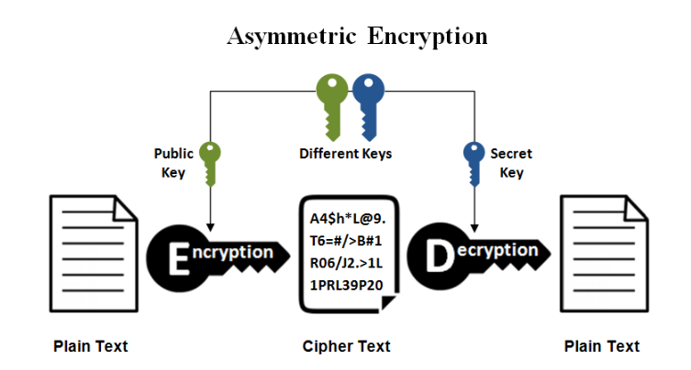
As stated in the previous slide, asymmetric encryption uses one key for encryption that is different from the key used for decryption. So, a criminal cannot calculate the decryption key based on the knowledge of the encryption key, and vice versa, in any reasonable amount of time.

Considering the figure, Bob and Alice, exchange a confidential message using public key encryption. So, they use an asymmetric algorithm.

With this exchange, Bob and Alice do not exchange keys prior to sending secret messages. Instead, they each have a separate padlock with separate corresponding keys.

For Alice to send a secret message to Bob, she must first contact him and ask him to send his open padlock to her. Bob sends the padlock but keeps his key.

Slide 5 - Asymmetric encryption algorithms

The most important asymmetric encryption algorithms are the following:
Diffie-Hellman (DH) key exchange
El-Gamal
Rivest-Shamir-Adleman (RSA)
Elliptic curve cryptography (ECC)

Slide 7 - Diffie-Hellman (DH) key exchange

Diffie-Hellman key exchange is a method of digital encryption that securely exchanges cryptographic keys between two parties over a public channel without their conversation being transmitted over the internet. The two parties use symmetric cryptography to encrypt and decrypt their messages.

Published in 1976 by Whitfield Diffie and Martin Hellman, it was one of the first practical examples of public key cryptography.

Diffie-Hellman key exchange raises numbers to a selected power to produce decryption keys.

The components of the keys are never directly transmitted, making the task of a would-be code breaker mathematically overwhelming.

The method doesn't share information during the key exchange. The two parties have no prior knowledge of each other, but the two parties create a key together.

Diffie-Hellman key exchange is commonly found in security protocols, such as Transport Layer Security (TLS), Secure Shell (SSH) and IP Security (IPsec).
Slide 8 - DH key exchange - figure

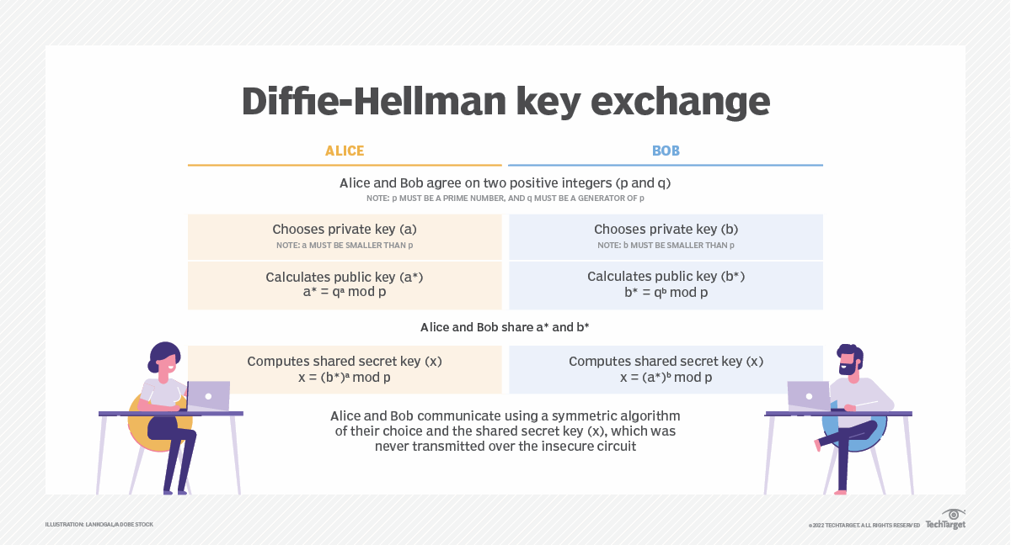

If two people, say Alice and Bob, want to communicate sensitive data over an open public network but want to avoid hackers or eavesdroppers, they can use the Diffie-Hellman key exchange method for encryption. This open public network could be at a cafe, for example.

Diffie-Hellman key exchange works by having both parties choose a private key, calculate a public key, share both computed keys and compute a shared secret key for secured communication.

- Alice and Bob agree on a large prime number p and a generator
- Alice chooses (randomly generates) a secret number a, and sends Bob the number A
- Bob chooses (randomly generates) a secret number b, and sends Alice the number B
- Alice computes B^a mod p = k
- Bob calculates A^b mod p = k

Slide 10 - Rivest-Shamir-Adleman (RSA)

The RSA algorithm is the basis of a cryptosystem which enables public key encryption and is widely used to secure sensitive data, particularly when it is being sent over an insecure network such as the internet.

RSA was first publicly described in 1977 by Ron Rivest, Adi Shamir and Leonard Adleman of the Massachusetts Institute of Technology, though the creation of a public key algorithm by British mathematician Clifford Cocks in 1973 was kept classified by the U.K.'s GCHQ until 1997.

Public key cryptography, also known as asymmetric cryptography, uses two different but mathematically linked keys -- one public and one private. The public key can be shared with everyone, whereas the private key must be kept secret.

RSA has become the most widely used asymmetric algorithm: It provides a method to assure the confidentiality, integrity, authenticity, and non-repudiation of electronic communications and data storage.

Slide 11 - Applications of RSA

Many protocols, including Secure Shell (SSH), OpenPGP, S/MIME, and SSL/TLS, rely on RSA for encryption and digital signature functions.

It is also used in software programs -- browsers are an obvious example, as they need to establish a secure connection over an insecure network, like the internet, or validate a digital signature.

RSA signature verification is one of the most commonly performed operations in network-connected systems.

Slide 12 - RSA figure
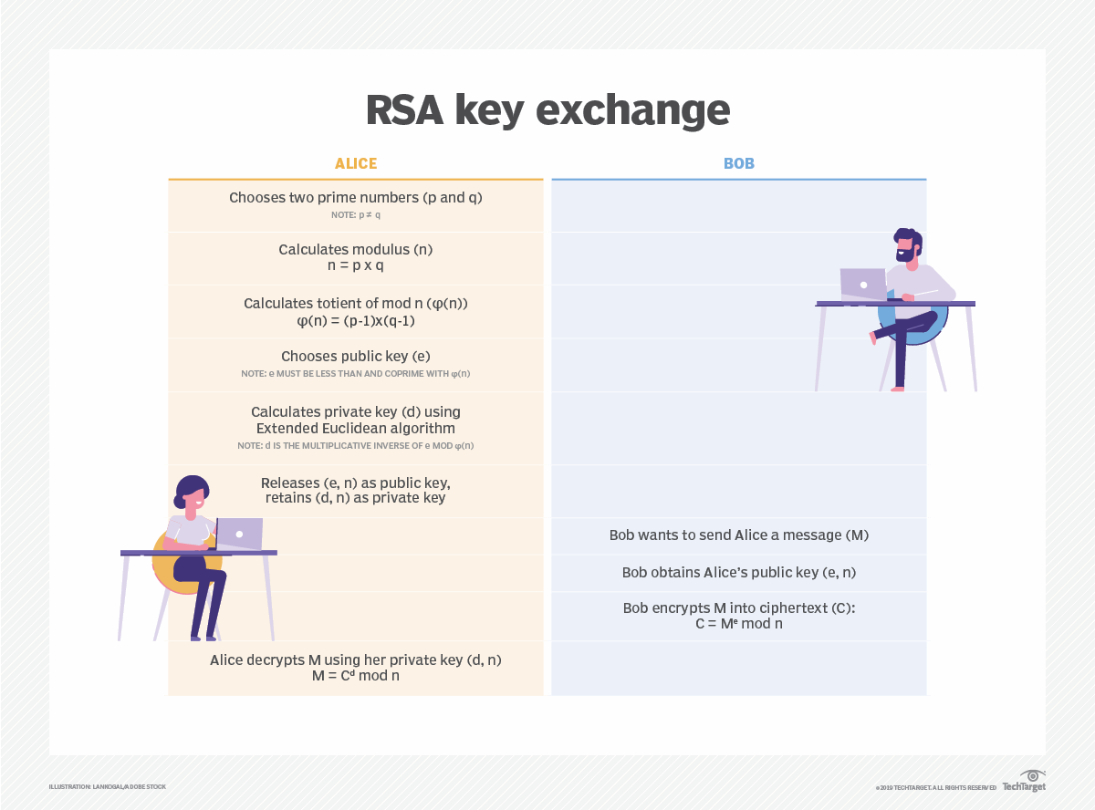
RSA derives its security from the difficulty of factoring large integers that are the product of two large prime numbers. Multiplying these two numbers is easy, but determining the original prime numbers from the total - or factoring - is considered infeasible due to the time it would take using even today's supercomputers.

The public and private key generation algorithm is the most complex part of RSA cryptography.

Two large prime numbers, p and q, are generated using the Rabin-Miller primality test algorithm. A modulus, n, is calculated by multiplying p and q. This number is used by both the public and private keys and provides the link between them. Its length, usually expressed in bits, is called the key length.

The public key consists of the modulus n and a public exponent, e, which is normally set at 65537, as it's a prime number that is not too large. The e figure doesn't have to be a secretly selected prime number, as the public key is shared with everyone.

The private key consists of the modulus n and the private exponent d, which is calculated using the Extended Euclidean algorithm to find the multiplicative inverse with respect to the totient of n.

Slide 14 - ElGamal algorithm

It is a public-key cryptosystem.

The scheme was proposed by Taher Elgamal, an Egyptian cryptographer, in 1984

This cryptosystem is based on the difficulty of finding discrete logarithms in a cyclic group.

ElGamal developed one version of the Diffie-Hellman algorithm. He perfected the Diffie-Hellman algorithm and obtained two algorithms that are used for encryption and authentication.

The ElGamal algorithm has not been patented and is therefore a less expensive alternative than others, as no license fee is required.

Slide 15 - Advantages of ElGamal

The advantages of ElGamal are related to three aspects: security, key distribution and digital signature.

Security: ElGamal is based on the discrete logarithm problem, which is considered to be a hard problem to solve. This makes it secure against attacks from hackers.

Key distribution: The encryption and decryption keys are different, making it easier to distribute keys securely. This allows for secure communication between multiple parties.

Digital signatures: ElGamal can also be used for digital signatures, which allows for secure authentication of messages.

Slide 16 - Disadvantages of ElGamal

The disadvantages of ElGamal are the following:

Slow processing: ElGamal is slower compared to other encryption algorithms, especially when used with long keys. This can make it impractical for certain applications that require fast processing speeds.

Key size: ElGamal requires larger key sizes to achieve the same level of security as other algorithms. This can make it more difficult to use in some applications.

Vulnerability to certain attacks: ElGamal is vulnerable to attacks based on the discrete logarithm problem, such as the index calculus algorithm. This can reduce the security of the algorithm in certain situations.

Slide 18 - Elliptic curve cryptography (ECC)

Elliptical curve cryptography (ECC) is a public key encryption technique based on elliptic curve theory that can be used to create faster, smaller and more efficient cryptographic keys.

ECC is an alternative to the Rivest-Shamir-Adleman (RSA) cryptographic algorithm and is most often used for digital signatures in cryptocurrencies, such as Bitcoin and Ethereum, as well as one-way encryption of emails, data and software.

ECC generates keys through the properties of an elliptic curve equation instead of the traditional method of generation as the product of large prime numbers.

ECC can yield a level of security that requires fewer computing resources to encrypt and decrypt data compared to alternative methods, like RSA

Slide 19 - ECC figure , resource intensive and slower to execute.
An elliptic curve is not an ellipse, or oval shape, but it is represented as a looping line intersecting two axes, which are lines on a graph used to indicate the position of a point. The curve is completely symmetric, or mirrored, along the x-axis of the graph.
ECC is based on the properties of a set of values for which operations can be performed on any two members of the group to produce a third member, which is derived from points where the line intersects the axes as shown with the green line and three blue dots in the below diagram labeled A, B and C.
Multiplying a point on the curve by a number produces another point on the curve (C).
Taking point C and bringing it to the mirrored point on the opposite side of the x-axis produces point D.
From here, a line is drawn back to our original point A, creating an intersection at point E.
This process can be completed n number of times within a defined max value. The n is the private key value, which indicates how many times the equation should be run, ending on the final value that is used to encrypt and decrypt data. The maximum defined value of the equation relates to the key size used.

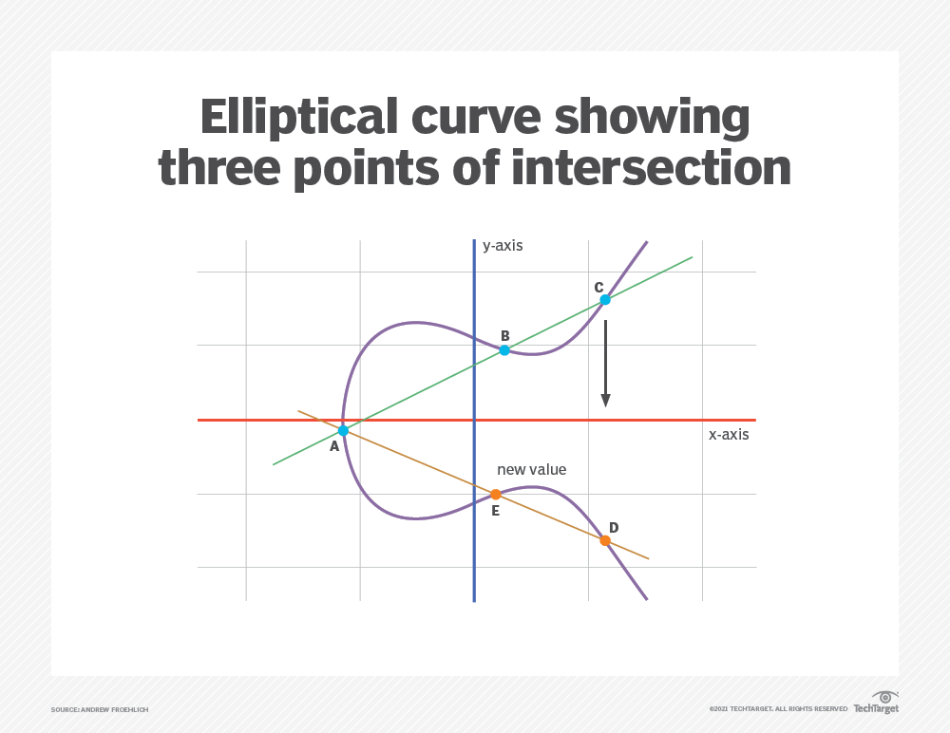

An elliptic curve is not an ellipse, or oval shape, but it is represented as a looping line intersecting two axes, which are lines on a graph used to indicate the position of a point. The curve is completely symmetric, or mirrored, along the x-axis of the graph.
ECC is based on the properties of a set of values for which operations can be performed on any two members of the group to produce a third member, which is derived from points where the line intersects the axes as shown with the green line and three blue dots in the below diagram labeled A, B and C.
Multiplying a point on the curve by a number produces another point on the curve (C).
Taking point C and bringing it to the mirrored point on the opposite side of the x-axis produces point D.
From here, a line is drawn back to our original point A, creating an intersection at point E.
This process can be completed in n number of times within a defined max value. The number n is the private key value, which indicates how many times the equation should be run, ending on the final value that is used to encrypt and decrypt data. The maximum defined value of the equation relates to the key size used.

Slide 20- Pros and cons of asymmetric encryption

The pros of asymmetric encryption include the following:

- Keys are never distributed or exchanged.
- Because private keys aren't transmitted or revealed, security is increased.
- Digital signatures enable sender authentication.
- It enables nonrepudiation.

The cons of asymmetric encryption include the following:

- It is slower than symmetric encryption.
- If an entity loses its key, messages can't be decrypted.
- Public key ownership isn't authenticated. Users must verify that their public keys belong to them.
- If a private key is stolen, an attacker could use it to decrypt their messages.

Asymmetric cryptography is subject to brute-force and man-in-the-middle attacks. Plus, if hackers know either user's key, they can use it to decrypt the data.

Slide 21 - Symmetric vs. asymmetric: Which is better?
When choosing an encryption algorithm, it's important to consider the type of data being encrypted. High-risk or sensitive data, such as confidential customer information, needs stronger encryption than marketing plans, for example.
Performance is another key factor. Asymmetric encryption is generally slower than symmetric encryption due to the creation of two keys instead of one. The tradeoff with symmetric encryption's use of the same key, however, is multiple chances for that key being exposed. Asymmetric encryption's distributed keys mean the keys are never distributed and, therefore, are more secure.

As noted, symmetric and asymmetric encryption algorithms have different vulnerabilities. It is important to understand the application to match the most appropriate algorithm with the particular use case.
In many scenarios, such as SSL/TLS, both asymmetric and asymmetric algorithms are used to boost security. Because asymmetric encryption is much slower than symmetric encryption, data is typically encrypted with a symmetric algorithm, and then the comparatively short symmetric key is encrypted using asymmetric encryption. This enables the key needed to decrypt the data to be securely sent to other parties along with the symmetrically encrypted data. In another example, Secure/Multipurpose Internet Mail Extensions, or S/MIME, uses an asymmetric algorithm for nonrepudiation and a symmetric algorithm for efficient privacy and data protection.
The landscape of cryptography is constantly changing. To stay abreast of the latest developments, we should follow the news and recommendations from standards bodies such as NIST.

HOMEWORK
- What is the most secure asymmetric encryption?

- Can asymmetric encryption be broken?

- What problem does asymmetric encryption solve that symmetric encryption does not?

- Does Bitcoin use asymmetric encryption?

